17th January 2019

**YOKOHAMA with SSANGYONG at the DAKAR 2019**

The dynamic rally duo, Oscar Fuertes and Diego Vallejo from the Ssangyong Motorsport team on the Ssangyong Rexton DKR fitted with YOKOHAMA tyres (Geolandar M/T G003), continue fighting against the odds in the current edition of the Dakar rally taking place in Peru. Having to contend with a smashed windshield in the early stages as well as other additional technical problems, they continue climbing places and are currently on 34th place overall.

The vehicle has been developed entirely in Spain and has a 6.2Litres V8 petrol engine especially prepared for the competition and offers 450hp.

The "GEOLANDAR M/T G003" is the new off-road tyre of the GEOLANDAR range for SUVs and Pick Ups from the Japanese premium tyre manufacturer YOKOHAMA. It provides extreme performance in off-road scenarios, from mud to rocks, dirt and gravel. The tread of the "GEOLANDAR M/T G003" includes a large mesh of blocks and sequential lamellae that helps the tyre to achieve excellent traction on various off-road surfaces. In addition, the "GEOLANDAR M/T G003" has a thickened sidewall with an aggressive block on the top side of the tyre. This block increases the resistance to cuts and wear.

Following the success of last year, with a meritorious completion of the race in their debut year, the Ssangyong team held high hopes for a good finish in the toughest challenge of the Dakar to date, with a total 5000km of racing of which 70% are in sand dunes.

This 41st edition of the Rally, which is on its last stage today has been arguably the hardest to date according to participants and organisers. Good luck to them!

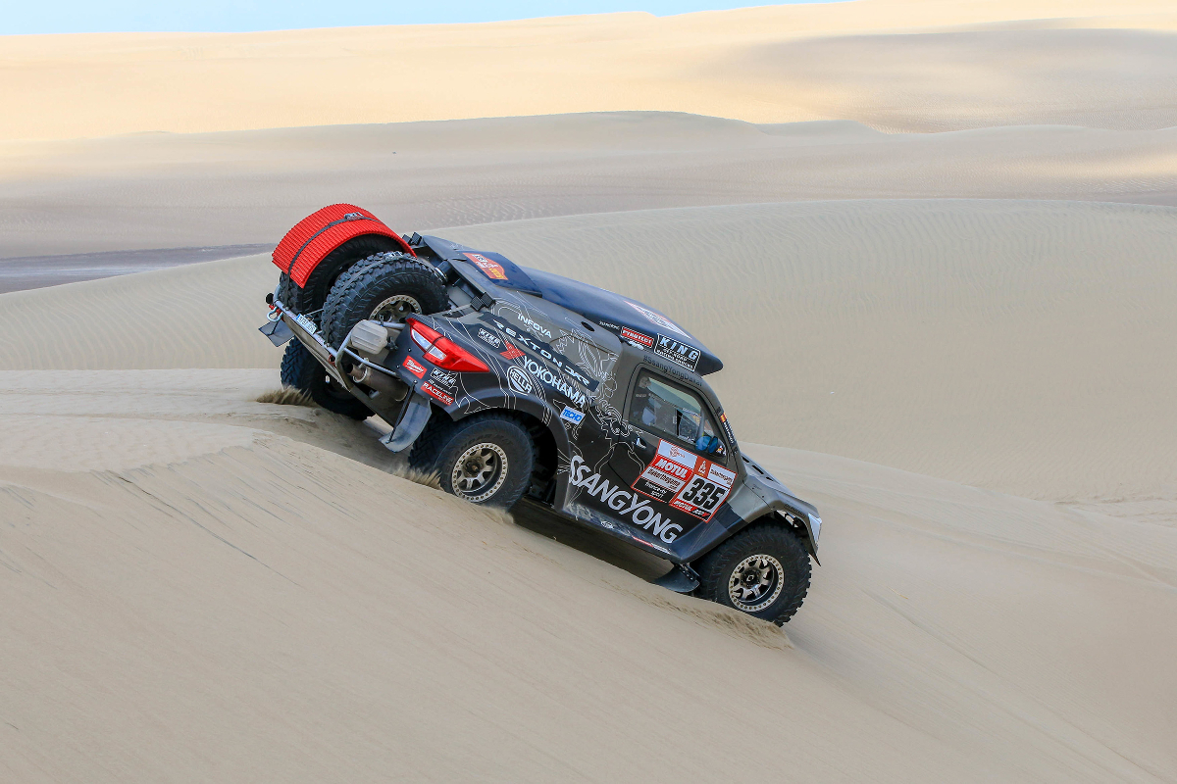

*Dakar 2019 Pic Ssangyong espana (1)*

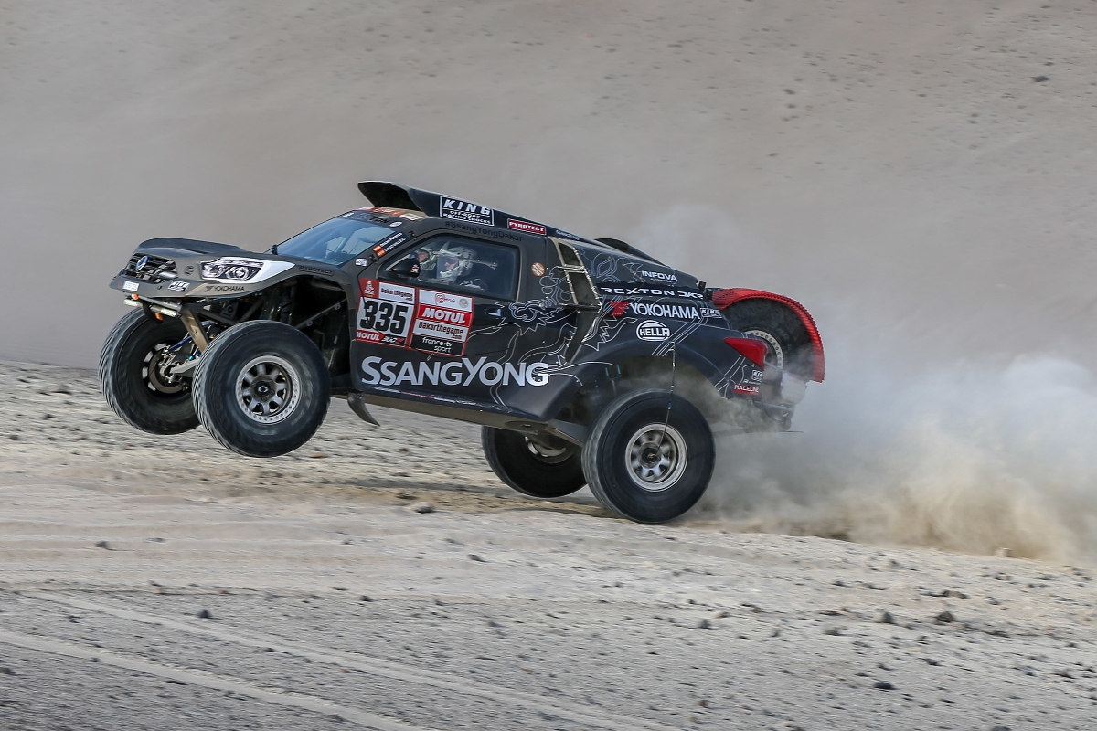

*Dakar 2019 Pic Ssangyong espana (2)*